Home Telehealth Reporting Enhancements (HTRE) Phase 3

Deployment, Installation, Back-Out, and Rollback Guide



June 2019

Version 4.0

Department of Veterans Affairs (VA)

Office of Information and Technology (OI&T)

**Revision History**

| Date | Version | Description | Author |
| --- | --- | --- | --- |
| 06/05/2019 | 4.0 | Updated Build Version #’s | Liberty IT Solutions |
| 03/01/2019 | 3.0 | Updated Build Version #’s | Liberty IT Solutions |
| 12/11/2018 | 2.1 | Appendix A added with Instructions to Upgrade WebLogic Portal | Liberty IT Solutions |
| 11/27/2018 | 2.0 | Updated Build Version #’s and Build Schedule | Liberty IT Solutions |
| 09/17/2018 | 1.0 | Initial Version | Liberty IT Solutions |

Table of Contents

1 Introduction 1

1.1 Purpose 1

1.1.1 Key Definitions 1

1.1.2 Statements of Understanding 2

1.2 Dependencies 2

1.3 Constraints 2

1.3.1 Plan Overview 2

2 Roles and Responsibilities 3

3 Deployment 4

3.1 Timeline 4

3.1.1 High-Level Schedule 4

3.1.2 Schedule Activities 5

3.2 Site Readiness Assessment 5

3.2.1 Deployment Topology (Targeted Architecture) 5

3.2.2 Site Information (Locations, Deployment Recipients) 5

3.2.3 Site Preparation 5

3.3 Resources 6

3.3.1 Facility Specifics 6

3.3.2 Hardware 6

3.3.3 Software 7

3.3.4 Communications 7

3.3.4.1 Deployment/Installation/Back-Out Checklist 7

3.3.5 Documentation 8

4 Installation 8

4.1 Pre-installation and System Requirements 8

4.2 Platform Installation and Preparation 9

4.3 Download and Extract Files 9

4.4 Database Creation 9

4.5 Installation Scripts 9

4.5.1 Install Package for Installing an IHTA Environment 9

4.5.2 Purpose of the Self-Extract Script 10

4.5.3 Self-Extract Script Files and Directories Listing 11

4.5.4 How to Create the Self-Extract Script 12

4.6 Cron Scripts 14

4.7 Access Requirements and Skills Needed for the Installation 14

4.8 Installation Procedure 15

4.8.1 Apache Web Server 15

4.8.2 WebLogic Portal Server Development 15

4.8.3 Apache Web Server Deployment 15

4.9 Steps for Deploying IHTA and the Static Help Files 15

4.9.1 IHTA Package Construction 16

4.9.2 Deploying IHTA to Production 16

4.9.3 Deploying IHTA Static Help Files to Production 17

4.10 Installation Verification Procedure 17

4.11 System Configuration 22

4.12 Database Tuning 22

5 Back-Out Procedure 22

5.1 Back-Out Strategy 22

5.2 Back-Out Considerations 22

5.2.1 Load Testing 22

5.2.2 User Acceptance Testing 22

5.3 Back-Out Criteria 22

5.4 Back-Out Risks 22

5.5 Authority for Back-Out 23

5.6 Back-Out Procedure 23

5.7 Back-Out Verification Procedure 23

6 Rollback Procedure 23

6.1 Rollback Considerations 23

6.2 Rollback Criteria 23

6.3 Rollback Risks 24

6.4 Authority for Rollback 24

6.5 Rollback Procedure 24

6.5.1 Steps for IHTA Deployment Rollback 24

6.5.2 Steps for IHTA Static Help Files Rollback 25

6.5.3 Steps for IHTA Startup 25

6.5.4 Steps for IHTA Shutdown 26

6.5.5 Backup Selection 26

6.5.6 Database Recovery Preparation 26

6.5.7 Database Point in time Restore 27

6.5.8 Database Recovery Follow-up 27

6.6 Rollback Verification Procedure 27

Appendix A Upgrade from WebLogic Portal 10.3.6 to WebLogic Portal 10.3.7 28

List of Tables

Table 1: Deployment Roles and Responsibilities 3

Table 2: High Level Milestones 4

Table 3: Site Preparation 5

Table 4: Facility-Specific Features 6

Table 5: Hardware Specifications 6

Table 6: Software Specifications 7

Table 7: Deployment/Installation/Back-Out Checklist 7

Table 8: Files and Directories Listed in Self-Extract Script 11

Table 9: Major Sections of the Build_IHT Script 12

Table 10: IHTA and Help Files for Deployment 15

Table 11: Smoke Test IHTA for Functionality 17

List of Figures

Figure 1: Oracle Installer Welcome Dialogue 29

Figure 2: Middleware Home Directory Dialogue 30

Figure 3: Products and Components Dialogue 31

Figure 4: JDK Selection Dialogue 32

Figure 5: Confirmation Dialogue 32

Figure 6: Product Installation Directories 33

Figure 7: Installation Summary Dialogue 34

Figure 8: Installing Patch Dialogue 35

Figure 9: Installation Complete Dialogue 36

Figure 10: Oracle WebLogic Upgrade Wizard Dialogue 37

Figure 11: Select WebLogic Version Dialogue 38

Figure 12: Select Domain to Upgrade Dialogue 39

Figure 13: Select Administration Server Dialogue 40

Figure 14: Select Upgrade Options Dialogue 41

Figure 15: Execute P13n Components Domain Upgrade Dialogue 42

Figure 16: Execute WLP Domain Upgrade Plugins Dialogue 43

Figure 17: Finalize Domain Upgrade 44

Figure 18: Database Upgrade Choise Dialogue 45

Figure 19: Associate DB Categories with Datasources Dialogue 46

Figure 20: Upgrade Complete Dialogue 47

# Introduction

This document describes the plan to deploy and install the Integrated Home Telehealth Application (IHTA) Version 14.5, as managed through the Home Telehealth Reporting Enhancements (HTRE) project.

## Purpose

The purpose of this plan is to provide a single, common document that describes how, when, where, and to whom the IHTA will be deployed. The plan also identifies resources, communications plan, and rollout schedule. Specific instructions for installation, back-out, rollback, transition to sustainment, and user training are supplied separately in stand-alone documents, in online help, or in change management systems, depending on the requirements of the operations organization.

### Key Definitions

**Deployment Design:** Phase of the solution life cycle in which architectural design and implementation specifications are developed and tested. The preparation of plans and specifications necessary to implement the solution are part of the Deployment Design phase. At the end of the Deployment Design phase, a solution is ready for implementation in the production environment.

Enterprise System Engineering (ESE) and Product Development (PD), as applicable, based on primary project ownership, are responsible for deployment design and complete release package specifications, including user and technical documentation, procurement, shipping, and training plans. Architectural design artifacts, release package specifics, and testing plans and results are vetted by the operations organization.

**Implementation:** Phase of the solution life cycle in which the newly designed or changed hardware, software, functionality, or process is installed into the production environment and activated. The specifications and plans created during Deployment Design steer the work that is performed during the Implementation phase.

The operations organization is responsible for installation and the installation schedule, selection and validation of shipping locations/schedule, site readiness to support installation, acceptance of equipment using asset inventory processes, coordinating and providing training (working with ESE and Product Development if applicable), communication, and vetting changes through the operations organization management.

**Release:** Release baseline is defined as the product build (software and hardware specifications) along with the body of documents that support testing, installation, operations, training, and support of the product. Projects will determine the release baseline early in the development cycle. Baseline components enter change control once the project is approved for deployment.

**ESE**: Responsible for release management and includes certifying production readiness. ESE must validate that the project owner has provided an adequate release package. ESE also validates the release baseline. As defined by the VA Office of Information & Technology (OI&T) Testing and Release checklist, the release package is the subset of documents that are provided to the operations organization, along with the product. The complete release package will be made available to the operations organization at or before deployment.

### Statements of Understanding

The Deployment Plan is developed with the following assumptions:

* PD is responsible for the software-only installation and during installation; a PD Project Manager (PM) leads projects. Enterprise Operations (EO) representatives participate as consulting team members. PD is responsible for design. Field Operations (FO), National Data Center Program (NDCP), and Austin Information Technology Center (AITC) are informed of design and testing issues.
* PD develops the Deployment and Installation Plan.
* New requirements that require Operations and Maintenance (O&M) resources must be funded. Deployment, installation, and ongoing maintenance costs (including capacity planning, recurring costs) must be identified and funded. All funding sources and issues should be resolved and documented prior to deployment and installation. PD should complete collaborative field-testing prior to deployment. Veteran-Focused Integration Process (VIP) Release Management will certify production readiness based upon the level of testing that has occurred prior to deployment. As part of the release baseline, this information would be identified in the Release Profile.
* The Office of Telehealth Services (OTS) (customer organization) will provide a training plan prior to deployment.

## Dependencies

This section is not applicable for IHTA.

## Constraints

This section is not applicable for IHTA.

### Plan Overview

Deployment and installation of IHTA is planned as a concurrent rollout to all Veterans Integrated Service Networks (VISN) at the same time.

Deployment will be performed by the PD team members with representatives from peer organizations, as needed. Installation will be performed by PD team members, along with representatives from peer organizations.

# Roles and Responsibilities

This section describes the teams who perform the steps described in this plan.

* Representatives from the teams listed in Table 1 perform the deployment and installation activities.

Table 1: Deployment Roles and Responsibilities

| ID | Team | Phase / Role | Tasks | Project Phase |
| --- | --- | --- | --- | --- |
| 1 | VIP | Deployment | Fully communicate ratified deployment topology | Per the Veteran-Focused Integration Process (VIP) |
| 2 | Product Development | Deployment | Deployment planning and scheduling (including orchestration with vendors) | Per VIP |
| 3 | Product Development | Deployment | Develop Communications Plan and key messages well in advance | Per VIP |
| 4 | Product Development | Deployment | Develop O&M Plan | Per VIP |
| 5 | National Home Telehealth Training Center | Deployment | Develop appropriate training materials | Per VIP |
| 6 | EO | Deployment | Ensure release package contains full complement of artifacts and authorizations required for deployment | Per VIP |
| 7 | EO | Deployment | Test for operational readiness | Per VIP |
| 8 | EO | Deployment | Release certification | Per VIP |
| 9 | EO | Deployment | Validate release baseline | Per VIP |
| 10 | Product Development | Deployment | Execute deployment | Per VIP |
| 11 | Product Development | Installation | Plan and schedule installation | Per VIP |
| 12 | Regional PM/ Field Implementation Services (FIS)/ Office of Policy and Planning (OPP) PM | Installation | Collaborate on Field Operations communication plan that touches various field operations stakeholders and execute the communications plan | Per VIP |
| 13 | Regional PM/FIS/OPP PM | Installation | Ensure authority to operate and that certificate authority security documentation is in place | Per VIP |

# Deployment

The deployment is planned as a single national rollout. This type of rollout is best suited for a Web-based system like IHTA.

* This section provides the schedule and milestones for the deployment.

## Timeline

The deployment is planned as a single national rollout. This type of rollout is best suited for a Web-based system like IHTA.

* This section provides the schedule and milestones for the deployment.
* The deployment and installation is scheduled to run for approximately 1 day, as depicted in section 3.1.1, High-Level Schedule.

In most Deployment Plans, Enterprise Operations (EO) maintains the master schedule in Microsoft Project Server, Field Operations, and Development (FOD) maintains its schedule in Clarity and provides site scheduling to meet parameters and milestones enumerated above. Given the agile methodology being used to develop and deploy IHTA, along with the limited scope of this software (only deployment/installation), there is no need for a Master Deployment Schedule. The high-level schedule contained in section 3.1.1 will suffice.

### High-Level Schedule

As noted below in the Deployment/Installation Schedule, the deployment targets the major milestones found in Table 2:

Table 2: High Level Milestones

| Milestones | Target Date |
| --- | --- |
| Software Quality Assurance Testing Completed | 12/14/18 |
| Section 508 Testing Completed | 12/24/18 |
| User Functionality Testing Completed | 12/14/18 |
| Software Baseline Defined | 11/30/18 |
| Deployment of IHTA to Primary Production Environment | 01/12/19 |
| Deployment of IHTA to Secondary Production Environment | 01/12/18 |
| Testing of IHTA in Primary Production Environment Completed | 01/12/18 |
| Testing of IHTA in Secondary Production Environment Completed | 01/12/18 |
| User Registration Completed (for new users) | N/A |
| User Training Completed (if applicable) | N/A |

### Schedule Activities

Given the small scope of this software-only deployment, and the Veteran-focused Integration Process (VIP) development/deployment methodology being employed to develop IHTA, no further detailed schedule activities are required.

## Site Readiness Assessment

This section discusses the locations that will receive the IHTA deployment. Topology determinations are made by ESE and vetted by FO, NDCP, and EO during the design phase as appropriate. FO does field site coordination unless otherwise stipulated.

### Deployment Topology (Targeted Architecture)

IHTA will be deployed using a primary/secondary data center topology. The Austin Information Technology Center (AITC) in Austin, TX, will be the primary production site, and the Philadelphia Information Technology Center (PITC) Philadelphia, PA, will be the secondary production site; however, at any given time, one site will act as the primary facility and the other site will act as the secondary facility. The function of the primary and secondary facilities will be shifted on a regularly scheduled basis to ensure that both facilities will function properly in either role when needed.

### Site Information (Locations, Deployment Recipients)

As noted above, deployment is planned at the following sites:

* Austin Information Technology Center (AITC) (Austin, TX)
* Philadelphia Information Technology Center (PITC) (Philadelphia, PA)

### Site Preparation

No changes will be required to accommodate IHTA at either (AITC) or (PITC). See Table 3 listed below.

Table 3: Site Preparation

| Site/Other | Problem/Change Needed | Features to Adapt/Modify to New Product | Actions/Steps | Owner |
| --- | --- | --- | --- | --- |
| N/A | N/A | N/A | N/A | N/A |

## Resources

This section describes hardware, software, and facilities required for the IHTA deployment and installation.

### Facility Specifics

No special facilities are required for IHTA installation/deployment. See Table 4 listed below.

Table 4: Facility-Specific Features

| Site | Space/Room | Features Needed | Other |
| --- | --- | --- | --- |
| N/A | N/A | N/A | N/A |

### Hardware

Table 5 describes hardware specifications for the IHTA servers.

Table 5: Hardware Specifications

| Required Hardware | Model | Version | Serial Numbers | Manufacturer | Quantity |
| --- | --- | --- | --- | --- | --- |
| AITC Server | Virtual Machine | N/A | Application/Web Server: | N/A | 1 |
| AITC Servers | Virtual Machine | N/A | SQL Server Database Server | N/A | 1 |
| PITC Server | Virtual Machine | N/A | Application/Web | N/A | 1 |
| PITC Server | Virtual Machine | N/A | SQL Server Database Server | N/A | 1 |

Please see Table 1, Deployment Roles and Responsibilities in section 2, Roles and Responsibilities for details about who is responsible for preparing the site to meet these hardware specifications.

### Software

Table 6 describes software specifications required at each site prior to deployment.

Table 6: Software Specifications

| Required Software | Make | Version | Configuration | Manufacturer | Other |
| --- | --- | --- | --- | --- | --- |
| Microsoft SQL Server | N/A | 2012 | N/A | Microsoft | N/A |
| Oracle WebLogic Portal Server | N/A | 11g Release 1 (10.3.7) | N/A | Oracle | N/A |
| Apache Web Server | N/A | Version 2.4.6 | N/A | Apache | N/A |
| Red Hat Enterprise Linux (RHEL) | N/A | 7.5 | N/A | Red Hat | N/A |

Please see Table 1, Deployment Roles and Responsibilities in section 2, Roles and Responsibilities for details about who is responsible for preparing the site to meet these software specifications.

### Communications

Not applicable.

#### Deployment/Installation/Back-Out Checklist

See Table 7 listed below.

Table 7: Deployment/Installation/Back-Out Checklist

| Activity | Day | Time | Individual Who Completed Task |
| --- | --- | --- | --- |
| Deploy | 01/12/19 | 9:00 AM EST – 1:00 PM EST | HTRE Phase 3 Product Development Team |
| Install | 01/12/19 | 9:00 AM EST – 1:00 PM EST | HTRE Phase 3 Product Development Team |
| Back-Out | 01/12/19 | 9:00 AM EST – 1:00 PM EST | HTRE Phase 3 Product Development Team |

### Documentation

Because PD will be responsible for the deployment, installation, and post-production support of IHTA, only limited formal documentation to support these activities will be produced. The following documents will be produced to support installation, deployment, and support of IHTA:

* HTRE_Phase3_IHTA_POM

**NOTE:** HTRE Phase 3, documentation is stored in the Rational Team Concert (RTC); CCHT_CM Project Area, and the Home Telehealth (HT) VA Software Documentation Library (VDL); <https://www.va.gov/vdl/application.asp?appid=154>.

# Installation

## Pre-installation and System Requirements

Integrated Home Telehealth Application (IHTA) is a Web-based portal application sponsored by the Veterans Health Administration (VHA) Office of Telehealth Services (OTS). IHTA is designed to provide a flexible, maintainable, and resilient platform for Home Telehealth (HT) business functions. Each business function supported by IHTA is constructed as an application module of IHTA. Current IHTA modules include My Profile, Administration, Manage Quality Improvement Reports (QIR) and HT Reports. IHTA access will be granted upon successful authentication using Department of Veterans Affairs (VA) Enterprise Two Factor Authentication (2FA) Single Sign on (SSO). Access to each IHTA module is restricted by user roles and permissions granted during the user registration process. Details on each module are provided below:

* **My Profile**: Allows the user to view his/her system information and adjust personal application settings, including audio instructions, multiple windows, and application window width and height.
* **Administration**: Provides IHTA administrators with the ability to approve or reject registrations, assign roles to users, and create and edit roles. This module also allows administrators to manage and schedule batch jobs (i.e., Weekly Vendor Compliance Report E-mail, Purge Completed Reports).
* **Manage Quality Improvement Reports**: The Manage QIR functionality allows Home Telehealth staff to electronically submit, process, track, and print QIRs that document quality and patient safety issues related to HT devices. This functionality replaces the manual VA Reporting and Processing Medical Materiel Complaints/ Quality Improvement Report form (VA Form 0729).
* **HT Reports**: Allows users to search on aggregate HT data from the Health Data Repository (HDR) to produce management-level reports.

Intended users of IHTA include National, Veterans Integrated Service Network (VISN) and Facility Administrators, Care Coordinators, Patient Services Assistants (PSA), VA Subject Management Experts, National Home Telehealth Training Center (NHTTC) staff, Program Office Managers, Vendors, and OTS Contract Office staff. Each IHTA module includes on-line help with content tailored specifically for that module.

IHTA is supported by the existing HT database, a relational database that stores data on patients enrolled in the HT program, the HT devices located in their homes, and the healthcare-related information they report using these devices. The HT database is updated weekly with this data, which is transmitted incrementally from the home-based medical devices and collected on data servers prior to its transmittal to the HT database.

IHTA is deployed into production at the Austin Information Technology Center (AITC) and the Philadelphia Information Technology Center (PITC).

## Platform Installation and Preparation

This release of IHTA is deployed to an existing platform. There is no system installation or configuration to be performed.

## Download and Extract Files

Not applicable for this application.

## Database Creation

IHTA Version 14.5 will function with the existing HT databases and will not require the creation of any additional database structure.

## Installation Scripts

### Install Package for Installing an IHTA Environment

The package is built and is represented as one file that is named **selfextract_IHT_ENV.bsx,** which is the only file needed to install an IHTA Environment.

* Prerequisites:
* The package file needs to be moved to the target host.
* The user running the script needs to have elevated privileges on the host.
* To start the installation, run the package as follows:
* chmod u+x selfextract_IHT_ENV.bsx;
* sudo bash selfextract_IHT_ENV.bsx ALL;

**NOTE:** The script should run to completion, but if not, you can refer to the log file name identified at the start of the script that is created in the /tmp directory to troubleshoot.

### Purpose of the Self-Extract Script

The purpose of the self-extract script is to automate the required installation and/or configuration of the following items:

* IHTA WebLogic domain
* WebLogic portal
* Apache Web Server
* WebLogic Apache Plugin
* CA Web Agent Single Sign-On Internal (SSOi)
* Secure Sockets Layer (SSL) Certificates (public and private keys)
* WebLogic (WLST) scripts
* WebLogic Domain Properties files
* IHTA Properties files

A privileged user with sudo rights with at least the following minimum permissions/privileges must execute the script:

* User <install_user>may run the following commands on vaausappiht800:
* (ALL) ALL
* (ALL) NOPASSWD: ALL

The self-extract script extracts the contents into a unique temporary directory under the /tmp directory. The script then calls/executes the main install script (build_iht.sh) for a seamless transition.

* The build_iht.sh script starts by checking prerequisites and installs the IHTA environment.
* During script execution, a log file is generated with time stamped details of all-important aspects of script execution.
* Upon completion of the IHTA environment installation, the script removes the unique temporary install working directory in the /tmp directory, leaving the IHTA environment with all required components of the IHTA.
* When the script runs to completion, the IHTA domain/environment is complete except for the deployment of the latest application help files, and the application CCHT.war file.

### Self-Extract Script Files and Directories Listing

Included in the self-extract script are the following files and directories that are listed in Table 8.

Table 8: Files and Directories Listed in Self-Extract Script

| File/Directory Name | Comment |
| --- | --- |
| aliases.sh | Not required but used as tools in development and troubleshooting. |
| BASELINE_DOMAIN | IHTA specific WebLogic domain template, containing all files necessary for the IHTA environment. |
| build_IHT.sh | Main Script used for the install. |
| ca-wa-12.51-cr08-linux-x86-64.bin | Binary install file for CA Web Agent SSOi. |
| ca-wa-12.51-cr08-linux-x86-64.bin.rsp | Response file for the silent install of the CA Web Agent SSOi. |
| decompress | Used in the creation of the self-extract script, this is the wrapper script that calls the build_IHT.sh script to run the IHTA installation. |
| env.properties | WebLogic domain/environment properties file. |
| functions.sh | Bash function (including the **f_LOG** function) to log output into a log file. |
| httpd.service | This is the adjusted system file, used in the override.conf to keep OS patching from overwriting the standard httpd.service file. |
| nodemanager.properties | Properties for the WebLogic Node Manager. |
| NONPROD.certs.tgz | SSL certificates and keys for Apache Web Servers for the DEV and SQA based IHTA environments. |
| PROD.certs.tgz | SSL certificates and keys for Apache Web Servers for PROD/DR and PRE-PROD based IHTA environments. |
| properties.file | Environment specific properties for all IHTA environments selected by the HOSTNAME of the install host machine. |
| selfextract_build.sh | The script builds the /tmp/**selfextract_IHT_ENV.bsx** from the contents of this directory. |
| set-apache-env.sh | Script used for Pathing CA Web Agent referenced in httpd.service file. |
| ssl.conf | Apache SSL Configuration file also used in WebLogic Proxy redirection and Static Web Help directives. |
| template_httpd.conf | Baseline httpd to replace the non-updated httpd.conf file, required since we found the Silent install of CA Web Agent does not update the httpd.conf file correctly. |
| WebAgent.conf | Used as a starting baseline for the CA Web Agent configuration. |
| WebLogic_home_bin | BIN directory with updated WebLogic Scripting Tool (WLST) scripts, plus IHTA specific WLST scripts. |
| WLSPlugin12.2.1.3.0-Apache2.2-Apache2.4-Linux_x86_64-12.2.1.3.0.zip | WebLogic/Apache Plugin files (latest release from November 2017). |

### How to Create the Self-Extract Script

The selfextract_build.sh script builds the /tmp/selfextract_IHT_ENV.bsx that is the only file needed to install an IHTA environment.

It creates a single self-executable file which has two sections, a top section (decompress script) and bottom section (Tar Gzip - TGZ file of the entire payload directory - minus decompress script).

1. The top portion of this script extracts the bottom portion into a unique directory in /tmp to be used by the build_iht.sh script.
2. The bottom portion of the file contains the compressed tar file of the contents of the IHTA payload directory, which contains the files described above.

Table 9 lists Major Sections of the Build_IHT script.

Table 9: Major Sections of the Build_IHT Script

| Term | Meaning |
| --- | --- |
| Test Sudo (introduced by the TEST_SUDO banner Note: all sections are introduced by banners) | This Section of the script is introduced by the TEST_SUDO banner and its purpose is to determine if the user executing the script has the appropriate permissions to execute. |
| Check Filesystem In | This section verifies that /u01 is indeed the mount point for the u01 filesystem. |
| Check WebLogic Installation | This section verifies the correct installation of WebLogic. |
| Check Apache Installation | This section verifies the correct installation of the Apache Web Server. |
| Check Java Installation | This section verifies the correct installation of Java (Java 8 required). |
| Let’s Start | This section is the actual start of the installation of the IHTA environment. |
| Variable Checks | This section checks that all necessary properties are available. Any properties that are not available will be questions presented to the user running the script. |
| Create Domain Directory | This section creates the IHTA environment’s home directory or /u01/domains/ directory. |
| Setup Java Bin Directory | This section creates soft links to the appropriate Java directories and inserts the proper paths into the PATH environment variable. |
| Copy WebLogic Domain Properties File | This section copies the IHTA environment property file into /home/weblogic and copies the WLST scripts into the /home/weblogic/bin directory. |
| Copy IHTA WebLogic Template Directory | This section copies recursively the IHTA template environment/domain directory into the /u01/domains/<iht_env> directory. |
| Setup StartupWebLogic.sh WebLogic Admin Server Script | This section configures the startWeblogic.sh script with the appropriate IHTA domain properties. |
| Setup /home/weblogic/bin Scripts | This section copies in the WLST scripts (used to administer the IHTA domains) and modifies the scripts for the specific IHTA environment. |
| Setup WebLogic Domain config.xml File | This section sets up the WebLogic config.xml file for the specific IHTA environment. |
| Setup WebLogic JDBC.xml File for Database Connectivity | This section modifies the JDBC.xml file for the specific IHTA Environment. |
| Setup WebLogic JDBC.xml File Encrypted Credentials | This section modifies the JDBC.xml files with encrypted usernames and passwords. |
| Setup WebLogic Environment Specific File | This section sets up the IHTA environment specific Properties file. |
| Setup Environment Symbolic Links | This section sets up symbolic links that are used in some to the WLST scripts. |
| Setup WebLogic Environment Properties File | This section sets up the specific IHTA environment properties file used by WebLogic. |
| Start WebLogic Admin Server | This section starts the WebLogic Admin Server for the IHTA environment (**NOTE:** If the Admin Server has already started, it will shut down and restart it). |
| Enroll IHTA WebLogic Domain in Node Manager | With the Admin Server running – this section enrolls the IHTA domain/environment into the WebLogic Node Manager. |
| Start WebLogic Node Manager | This section starts the WebLogic Node Manager, configures, and re-starts the WebLogic Node Manager. |
| CA Webagent Installation SSOi | This section configures all properties needed for the IHTA environment to interact with the CA Web Agent. |
| CA Webagent Configuration SSOi | This section configures all properties needed for the IHTA environment to interact with the CA Web Agent. |
| Install and Configure WebLogic Apache Plugin | This section installs and configures the latest WebLogic Apache Plugin. |
| Apache Web Server Configuration | This section performs all configurations necessary for the Apache Web Server to be able to interface with the CA Web Agent, WebLogic Apache Plugin, IHTA and help files. |

**NOTE:** This package and scripts within are for specific versions of the following products listed below. As the products are upgraded, changes may be required.

* Red Hat Enterprise Linux (RHEL) 7.5
* Apache Web Server 2.4.6
* WebLogic Portal 10.3.7
* WebLogic Plugin 12.2.1.3.0
* CA WebAgent 12.51-cr08

## Cron Scripts

Not applicable for this application.

## Access Requirements and Skills Needed for the Installation

A privileged user with sudo rights with at least the following minimum permissions/privileges must execute the script:

* User <install_user> may run the following commands on vaausappiht800:
* (ALL) ALL
* (ALL) NOPASSWD: ALL

The skill set of a WebLogic, Linux, Windows and SQL Server expert is needed to perform the installation.

## Installation Procedure

### Apache Web Server

The Apache Web Server is installed by Information Operations (IO) and is part of their baseline (Golden Image Install of Red Hat Linux). All remaining steps to configure Apache are performed by the installation package and scripts in section 4.5, Installation Scripts.

### WebLogic Portal Server Development

IHTA is designed and implemented as a Java Enterprise Edition Web Application; hence, IHTA is packaged as an Enterprise Web Application (WAR) file. The steps to deploy the ccht.war file onto the IHTA Domain on the Production Web Application Servers are in section 4.5, Installation Scripts.

### Apache Web Server Deployment

IHTA contains static content, such as HTML files, for its on-line help files. The steps to deploy IHTA static content onto the Production Web Servers are in section 4.5, Installation Scripts.

## Steps for Deploying IHTA and the Static Help Files

All files necessary for an IHTA deployment will be staged in the /tmp/ihta_latest directory on a (AITC-Linux-400) server and will be packaged in one file called NEW_IHTA_REL.tgz. The Project Development (PD) Team will coordinate with Information Operations (IO) Linux System and WebLogic Administrators to complete the staging, packaging, deployment and rollback if necessary. All files in the package will be owned by weblogic:weblogic so the IO WebLogic Administrator has the necessary privileges to perform the detailed steps. Table 10 lists IHTA and Help files for deployment.

* Deploying the IHTA (CCHT.war) file:
* Copy the CCHT.war and the CCHT.war.md5 files to the appropriate /u01/domains/<ihta_env>/appStage/ directory.
* Deploying the static IHTA help files:
* Copy the IHTA static help files into the /var/www/html/MAINT> directory.

Table 10: IHTA and Help Files for Deployment

| File Name | Purpose |
| --- | --- |
| ccht.war | Web base IHTA archive file |
| ccht.war.md5 | Web base IHTA archive file |
| admin.zip | Administration Module help files |
| dmp.zip | DMP Module help files |
| external.zip | Launching external applications files |
| hdi.zip | Inventory Tracker Module archive files |
| ihta.zip | Top level application help files |
| main.zip | Main application help files |
| profile.zip | Profile Module help files |
| qir.zip | QIR Module help files |
| register.zip | Registration Module help files |
| reports.zip | Reports Module help files |

### IHTA Package Construction

**NOTE:** The below Linux commands end with a semicolon, and the Linux command support information notes are in parenthesis.

* chown -R weblogic:weblogic /tmp/IHTA_latest/;
* chmod -R 755 /tmp/IHTA_latest/;
* tar -czvf NEW_IHTA_REL.tgz /tmp/IHTA_latest/;
* md5sum NEW_IHTA_REL.tgz > NEW_IHTA_REL.tgz.md5;
* chown weblogic:weblogic NEW_IHTA_REL.tgz*;
* rm -f /tmp/IHTA_latest/*;
* mv NEW_IHTA_REL.tgz* /tmp/IHTA_latest;

### Deploying IHTA to Production

**NOTE:** The below Linux commands end with a semicolon, and the Linux command support information notes are in parenthesis.

* WebLogic Administrator as weblogic user:
* scp vaausappiht###:/tmp/IHTA_latest/NEW_IHTA_REL.tgz* /tmp/IHTA_latest/; (from Linux_400 Pre-Production)
* cd /tmp/IHTA_latest; (Logged into Linux_200 as weblogic)
* sudo md5sum -c NEW_IHTA_REL.tgz.md5; (checks the package integrity)
* sudo tar -xzvf NEW_IHTA_REL.tgz;
* mkdir ~domains/ihta_prod1035/appStage/14.5.0.#####/; (version number will be provided)
* cp ./ccht* ~domains/ihta_prod1035/appStage/14.5.0.#####/; (version number will be provided)
* cd domains/ihta_prod1035/appStage/14.5.0.#####/; (version number will be provided)
* md5sum -c NEW_IHTA_REL.tgz.md5; (output should say OK - checks integrity of ccht.war file)
* cd ~; (change back to the weblogic home directory)
* getstatus.sh ppd.properties; (If the application JVM MS1 is running)
* stopserver.sh prod.properties MS1; (Shutdown JVM/IHTA Application)
* undeploy.sh prod.properties; (Un-deploy the previous version)
* rm -rf /u01/domains/ihta_prod1035/servers/MS1; (clean out old app cached files)
* deploy.sh prod.properties /u01/domains/ihta_prod1035/appStage/14.5.0.#####/ccht.war;
* appstatus.sh prod.properties; (output should say NEW)
* startserver.sh prod.properties MS1;
* appstatus prod.properties; (output should say ACTIVE)
* getstatus prod.properties; (output shows Admin and MS1 running)

### Deploying IHTA Static Help Files to Production

**NOTE:** The below Linux commands end with a semicolon, and the Linux command support information notes are in parenthesis.

* WebLogic Administrator as weblogic user:
* cd /var/www/html/maint;
* rm IHTA_help_*.tgz; (remove old help files archive)
* tar -czvf IHTA_help_YYYYMM.tgz ./help/; (archive the current static help files to IHTA_help_201804)
* rm -rf ./help/*; (remove the old help files)
* cd help;
* cp /tmp/IHTA_latest/*.zip ./; (move the new compressed help files in place)
* for x in *.zip; do unzip ${x}; done (decompress static help files)
* for x in *.zip; do rm -f ${x}; done (remove static help files)
* Linux Administrator with sudo privilege:
* systemctl restart httpd; (IO Linux System Administrator restarts Apache Web Server)

The PD Team performs a Smoke Test of the IHTA WebLogic Environment and Application Setup.

If the Smoke Test in Table 11 is successful, then the Deployment is complete. If the Smoke Test fails, a decision will be made at that time to either fix or rollback.

## Installation Verification Procedure

Use the steps in Table 11 to test the main functionality of IHTA to ensure the installation of IHTA is successful.

Table 11: Smoke Test IHTA for Functionality

| **Step #** | **Action** | **Expected Results** |
| --- | --- | --- |
| 1 | Open IHTA | SSO page appears |
| 2 | Click on the ‘Sign In with VA PIV Card graphic’ | Windows Security pop-up box appears requesting your PIV certificate and pin number |
| 3 | Enter pin number and click ‘Ok’ | SSO log on succeeds. IHTA homepage appears |
| 4 | Verify Version # is the Version # included in the build e-mail received from the Configuration Manager | IHTA Version at bottom of page matches version included in e-mail |
| 5 | Login into application | IHTA home page is displayed |
| 6 | Once you are logged in as a National Admin | IHTA homepage is displayed   * National Admin has tabs for my profile, administration, and Manage QIRs |
| 7 | Click blue question mark on right side of application | IHTA Help page loads |
| 8 | Close Help page/tab that opened | IHTA homepage is displayed |
| 9 | Click blue help link in footer | IHTA Help page loads |
| 10 | Repeat Step 8 | Repeat Step 8 |
| 11 | Click My Preferences under My Profile tab | User Name, User ID, and Assigned Roles are shown   * The only role shown for this logged in user is National Administrator |
| 12 | Click Manage Registrations under Administration tab | List of Registration(s) are shown with a Pending status |
| 13 | Highlight an existing registration | Registration is selected   * Buttons for Approve, Deny, and Cancel appear |
| 14 | Click Approve | Approve Registration page loads with user information |
| 15 | Check Program Support Assistant | Program Support Assistant (PSA) box is checked |
| 16 | Click Reset | User info is reloaded and PSA role is not checked |
| 17 | Click Cancel | Confirmation appears “All of the unsaved data will be lost. Do you still want to cancel?” click Yes   * You are brought back to the Manage Registrations page |
| 18 | Repeat Step 13 | Repeat Step 13 |
| 19 | Click Deny | Message box appears, “are you sure you want to deny this registration.”   * OK and Cancel buttons appear * Click “OK” * Deny Registration page loads with user information * Verify there is a required Registration Denied Reason field |
| 20 | Click Cancel | Confirmation appears “All of the unsaved data will be lost. Do you still want to cancel?” click Yes   * Manage Registrations page loads |
| 21 | Click Manage Users under Administration tab | Manage Users page loads with search field available to search by User ID, or user's full Last Name, or user's full Last Name and full or partial First Name. |
| 22 | Click Search | Error Message displayed  Error Message(s):   * User ID or Full Last Name is required |
| 23 | Input ihtaadmin for User ID | User input shows in field |
| 24 | Input ihtaadmin for Last Name | User input shows in field |
| 25 | Repeat Step 22 | Error Messages displayed indicating user should only fill out one of the required fields not both |
| 26 | Erase input from Last Name | User input is deleted from field |
| 27 | With ihtaadmin in the User ID Field Only  Click Search | Manage Users page loads with ihtaadmin information |
| 28 | Click Cancel | Manage Users screen with search fields is displayed |
| 29 | Click Mange Roles under Administration tab | Manage Roles loads with list of Roles and options for add and cancel |
| 30 | Click Add | New Role page loads with editable fields to make a new role |
| 31 | Click Cancel | Confirmation appears “All of the unsaved data will be lost. Do you still want to cancel?” click Yes   * Manage Roles page is displayed |
| 32 | Click Manage Scheduled Jobs under Administration tab | Manage Scheduled Jobs page loads with list of jobs |
| 33 | Click “Resume All” or Click “Pause All” depending on what you find in an environment | Scheduled Job Status changes |
| 34 | Highlight PurgeCompleteReports | List of options appear on bottom of screen |
| 35 | Click Execute | Success Message appears alerting user job was executed successfully |
| 36 | Click Config | Config Scheduled Job popup is displayed   * Job Status is “Paused” when Scheduled Job Status is “Paused” |
| 37 | Click Cancel | List of scheduled jobs is displayed |
| 38 | Click Schedule | Reschedule Scheduled Job popup is displayed |
| 39 | Click Change | Editable job schedule is displayed |
| 40 | Click Cancel | Reschedule Scheduled Job popup is displayed |
| 41 | Click Cancel | List of scheduled jobs is displayed |
| 42 | Click History | Scheduled Job History popup is displayed with a list of entries of jobs that have been run |
| 43 | Click Cancel | List of scheduled jobs is displayed |
| 44 | Click Active tab | Active view loads with no data available in table |
| 45 | Click Refresh | Active view loads with same message |
| 46 | Click Cancel | IHTA homepage is displayed |
| 47 | Click Search All under Manage QIRs tab | QIR entries are displayed   * Select any QIR * National Administrator has the edit button available when clicking on any QIR * Unselect your selection |
| 48 | Click Excel | Full list of QIRs is opened in an Excel Spreadsheet |
| 49 | Close Excel | Search All QIRs page is displayed |
| 50 | Apply search filters to QIR | Depending on what search filters the user uses, when searching the results are affected |
| 51 | Logout of application and log back in as a QIR Originator | Homepage is displayed   * QIR Originator has tabs for My Profile and Manage QIRs with the options to Add a New QIR |
| 52 | Click New under Manage QIRs tab | New QIR page loads |
| 53 | Fill out all required fields for a Test QIR | All fields with red asterisk are filled out |
| 54 | Attach a document | A document is attached to the QIR |
| 55 | Click Submit | QIR success message appears   * A blank QIR form is loaded |
| 56 | Click View My under Manage QIRs tab | QIR entries are displayed |
| 57 | Highlight Test QIR just created | Buttons for edit, pdf, refresh, and cancel appear at bottom |
| 58 | Click PDF | PDF version of current QIR loads in new tab |
| 59 | Exit PDF | Tab closes   * View My QIRs page is displayed |
| 60 | Click Edit | Test QIR information loads and is editable |
| 61 | Click Search All Under Manage QIRs tab | QIR entries are displayed |
| 62 | Highlight Test QIR just created by you | Buttons for edit, pdf, refresh, and cancel appear at bottom   * For QIRs not created by you buttons view, pdf, refresh and cancel appear |
| 63 | Select Census Activity report under HT reports | Census Activity GUI is displayed |
| 64 | Select National Totals, Week ending 7/22/17, all modalities, all vendors and show vendors and click generate report | A Census activity report is generated.   * The report includes a populated table with columns Modality Totals and National Totals. |

## System Configuration

WebLogic Portal was updated in a previous release from 10.3.6 to 10.3.7 to be TRM compliant. Please refer to Appendix A.

## Database Tuning

IHTA Version 14.5 deployment will not require any database configuration changes or database structure alterations to the existing HT databases.

# Back-Out Procedure

This section outlines the back out procedures for IHTA.

## Back-Out Strategy

Any database structure or data changes introduced during a release will be removed on a case-by-case basis. Back-out scripts are included as part of the database change package and will be applied as needed to correct any failed area during the release deployment.

## Back-Out Considerations

### Load Testing

Not applicable for this application.

### User Acceptance Testing

Not applicable for this application, there are no functional changes.

## Back-Out Criteria

The back-out criteria are errors in the log files, other application errors, and the application performance not meeting the project standards.

Based on the criteria available about a failure, the initial strategy will be to work with IT Operations and Services (ITOPS) staff that is assisting with the IHTA release deployment to correct the problem.

## Back-Out Risks

Not applicable for this application.

## Authority for Back-Out

Product Development (PD) would issue the authority to back-out.

## Back-Out Procedure

Refer to section 6, Rollback Procedure for the back-out procedure.

The back-out procedure will be coordinated between HTRE product development staff members and ITOPS technical staff assigned to deploy the IHTA release. Appropriate actions will be taken as needed to first correct the issue and failing that, reconfigure the release to work around any minor failures. The last option will be to revert back to the prior IHTA release and revisit IHTA release deployment at a future date.

## Back-Out Verification Procedure

Refer to section 4.10, Installation Verification Procedure for the back-out verification procedure.

# Rollback Procedure

## Rollback Considerations

Since the database structure or data requirements of the HT database will not be altered to support IHTA Version 14.5, HT database rollback will only be considered if data is introduced during IHTA smoke testing following IHTA deployment to production. Database recovery and rollback will only occur if manual data correction by PD cannot be employed as an alternative.

## Rollback Criteria

The following criteria will be used to evaluate the need for database recovery:

* Data is logically introduced during testing of the IHTA Version 14.5 application.
* Users have not been allowed access to IHTA following upgrade.
* External data feeds to HT database have not been restarted.
* The amount of time that has passed since IHTA allowed user access.

Since IHTA Version 14.5 does not introduce HT database structural or data changes, PD will consider manual data correction over HT database recovery.

## Rollback Risks

The greatest rollback risk can be loss of data. The amount of data loss will depend on when it is determined that a rollback is potentially needed in relation to the amount of time that has passed since the IHTA was made available to the users following deployment of IHTA Version 14.5.

## Authority for Rollback

The PD team will be contacted to issue authority for database rollback.

## Rollback Procedure

Home Telehealth product development team members will coordinate with AITC DBA staff to perform database recovery. The form of database recovery followed will depend on the type of database failure that requires a recovery effort to be initiated.

Recovery of the database to a prior point in time will require restoring the database from a full backup and applying the transaction logs necessary to bring the database state to the decided upon point in time. All due consideration should be given to the impact that this form of database recovery will have as data will be lost. Performing a database rollback recovery should only be considered after all other possible approaches to data correction have been found to have a greater impact than a point-in-time recovery. The following subsections describe the process for rolling back a database to a desired point in time.

### Steps for IHTA Deployment Rollback

The details for rolling back IHTA to a previous version in production are listed below.

**NOTE:** The below Linux commands end with a semicolon, and the Linux command support information notes are in parenthesis.

* WebLogic Administrator as weblogic user:
* getstatus.sh ppd.properties; (If the application JVM MS1 is running)
* stopserver.sh prod.properties MS1; (Shutdown JVM/IHTA Application)
* undeploy.sh prod.properties; (Undeploy version 14.5.0.##### due to failure)
* rm -rf /u01/domains/ihta_prod1035/servers/MS1; (clean out old app cached files)
* deploy.sh prod.properties /u01/domains/ihta_prod1035/appStage/14.0.0.00801/ccht.war; (where <14.0.0.00801> is the Previous Version of the IHTA Application)
* appstatus.sh prod.properties; (output should say NEW)
* startserver.sh prod.properties MS1; (Start the JVM/IHTA Application)
* appstatus prod.properties; (output should say ACTIVE)
* getstatus prod.properties; (output shows Admin and MS1 running)

### Steps for IHTA Static Help Files Rollback

**NOTE:** The below Linux commands end with a semicolon, and the Linux command support information notes are in parenthesis.

* WebLogic Administrator as weblogic user continued:
* cd /var/www/html/maint;
* rm -rf ./help/*; (remove the New Version help files)
* tar -xzvf IHTA_help_YYYYMM.tgz ./help/; (restore the previous version static help)
* Linux Administrator with sudo privilege:
* systemctl restart httpd; (IO Linux System Administrator restarts Apache Web Server)

### Steps for IHTA Startup

The details of starting IHTA in production are listed below.

**NOTE:** The below Linux commands end with a semicolon, and the Linux command support information notes are in parenthesis.

* WebLogic Administrator as weblogic user:
* cd; (make sure user in weblogic home directory)
* ps -ef | grep java; (should be no java processes running)
* domains/ihta_prod1035/startWeblogic.sh; (Start the WebLogic Admin Server)
* appstatus.sh prod.properties; (output should show NEW meaning application is deployed but not running)
* startserver.sh prod.properties MS1; (Start the JVM/IHTA Application)
* appstatus prod.properties; (output should say ACTIVE)
* getstatus prod.properties; (output shows Admin and MS1 running).
* Linux Administrator with sudo privilege:
* systemctl restart httpd; (IO Linux System Administrator restarts Apache Web Server)

### Steps for IHTA Shutdown

The details to shut down IHTA in production are listed below.

**NOTE:** The below Linux commands end with a semicolon, and the Linux command support information notes are in parenthesis.

* WebLogic Administrator as weblogic user:
* cd; (make sure user is in the weblogic home directory)
* getstatus.sh prod.properties; (output shows Admin and MS1 running)
* appstatus.sh prod.properties; (output should say ACTIVE)
* stopserver.sh prod.properties MS1; (Shutdown JVM/IHTA Application)
* appstatus prod.properties; (output should say NEW)
* getstatus prod.properties; (output shows only Admin server is running)
* killall java; (Kill the remaining Nodemanager and Admin Server Java Processes)
* ps -ef | grep java; (confirm no Java processes running)
* Linux Administrator with sudo privilege:
* systemctl stop httpd; (IO Linux System Administrator restarts Apache Web Server)

### Backup Selection

Select the full database backup that is prior to and closest to the point in time that the database will be recovered to. If the backup is on external medium, transfer it to a folder on the primary database server so that it is directly available to the database software. Select all transaction log backups that were taken twenty-four hours prior to the database backup you have selected, and all transaction log backups taken up to, include the point in time that you have targeted, to recover the database. If the transaction log backups are on external medium, transfer all to a folder on the primary database server so that they are directly available to the database software.

### Database Recovery Preparation

1. Make sure all application use of the database is shutdown. Place the database in the restricted access mode and clear all current user connections.
2. Shutdown database replication to the secondary server, since the same data issue that is influencing the primary also affects the secondary database. The replication database will need to be rebuilt once the recovery is completed.
3. Though it is the database that needs to be corrected, it also represents the starting point if the recovery effort fails for any reason. Take a full backup of the database. Save the backup in a file just in case it is needed to rebuild and restart the recovery.

### Database Point in time Restore

1. Coordinate with the database administrator (DBA) on duty at the data center hosting the primary Home Telehealth database to perform the database restore.
2. Provide the data center DBA with the point in time that the database will be recovered.
3. Support the data center DBA as they collect DB backup and transaction log files and perform database recovery procedures.

### Database Recovery Follow-up

1. Once recovery is completed, provide the data center DBA scripts to:
2. Validate the database functionality.
3. Identify the last Health Level 7 (HL7) messages processed to the database.
4. Determine the last data built to the database from the IHTA.
5. Have the data center DBA:
6. Create a full database backup and a backup of the transaction log.
7. Copy the backups to the secondary database server.
8. Perform the steps above to recover the database on the secondary database server.
9. Restart database replication.
10. Follow-up with CNS sustainment team members to collect and run any lost HL7 survey or census messages. Notify users of any lost IHTA data.

## Rollback Verification Procedure

PD will review timestamps within the database in comparison to audit message logs located elsewhere within the database server to validate that the database has been recovered to the correct point in time prior to the data failure point.

1. Upgrade from WebLogic Portal 10.3.6 to WebLogic Portal 10.3.7
   1. **Conventions**

appstatus.bsh prod.properties Font for command lines entries

-> Pointer for output

--- STATE_ACTIVE --- Output format

[Note: No STATE is displayed] Note Format

Examples:

dzdo su – weblogic

appstatus.bsh prod.properties -> --- STATE_ACTIVE ---

appstatus.bsh prod.properties [Note: No STATE is displayed]

* 1. **Starting Procedure**

1. Shutdown all WebLogic Portal (WLP) Processes

dzdo su – weblogic

appstatus.bsh prod.properties -> --- STATE_ACTIVE ---

stopserver.sh prod.properties MS1

appstatus.bsh prod.properties -> --- STATE_NEW ---

grep ccht.war domains/ihta_prod/config/config.xml -> <source-path>appStage/12.5.0.00601/ccht.war</source-path>

undeploy.sh prod.properties

appstatus.bsh prod.properties [Note: No STATE is displayed]

killall java

ps -ef | grep java -> weblogic 58067 56387 0 09:31 pts/0 00:00:00 grep --color=auto java

1. Backup WLP 10.3.6 Domain

cd domains/ihta_prod/

find . | wc -l -> 39606 [Note the number of files backed up]

tar -czvf ../sqa_rel_bu-20181128.tgz ./

cd ..

pwd -P -> /u01/domains

ls -la *.tgz [Note confirm *.tgz backup file is here]

tar -tvf sqa_rel_bu-20181128.tgz | wc -l -> 39606 [Note the number of files backed up exactly matches above]

1. Backup WLP 10.3.6 Application Installation Directories

cd /u01/app/oracle

ll weblogic [Note weblogic is a soft link pointing to weblogic-portal-10.3.6]

rm -f weblogic

cd weblogic-portal-10.3.6

pwd -P [Note confirm you are in the **/u01/app/oracle/ weblogic-portal-10.3.6** directory]

find . | wc -l -> **8324** [Note the number of files backed up]

cd ..

pwd -P -> /u01/app/oracle

ls -la *.tgz [Note confirm *.tgz backup file is here]

tar -tvf 600wlp10.3.6_bu_20181128.tgz | wc -l -> **8324** [Note the number of files backed up exactly matches above]

1. Prepare for the Installation of WebLogic Portal 10.3.7

cd /u01/app

ll -> drwxrwxr-x. 5 weblogic weblogic 141 Nov 28 12:28 oracle

-rw-r-----. 1 weblogic weblogic 1045549480 Nov 29 11:07 portal103_generic.jar

cd oracle

ln -s weblogic-portal-10.3.7 weblogic

cd weblogic

pwd -P -> /u01/app/oracle/weblogic-portal-10.3.7

**NOTE: GET X11 RUNNING ON WEBLOGIC SA’s WORKSTATION CONNECT TO SERVER AS WEBLOGIC AND TEST WITH XCLOCK**

* 1. **Install WebLogic Portal 10.3.7**

cd /u01/app

java -d64 -jar portal103_generic.jar

1. Click **Next**

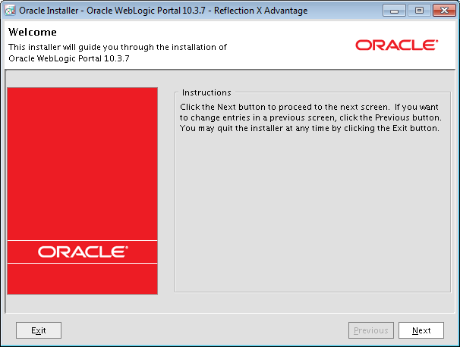

Figure 1: Oracle Installer Welcome Dialogue

1. Select **Create a new Middleware Home**
2. Enter the following into the **Middleware Home Directory** field: **/u01/app/oracle/weblogic-portal-10-3-7**
3. Click **Next**

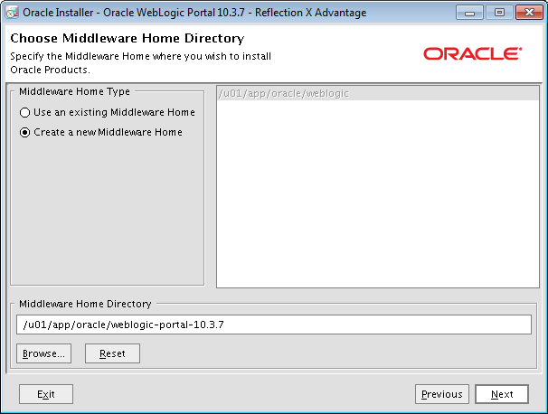

Figure 2: Middleware Home Directory Dialogue

**NOTE: GET THROUGH THE EMAIL NOTIFICATION SCREENS INDICITING THAT YOU DO NOT WANT TO BE EMAILED/NOTIFIED**

1. Accept the defaults on **Choose Products and Components** dialogue
2. Click **Next**

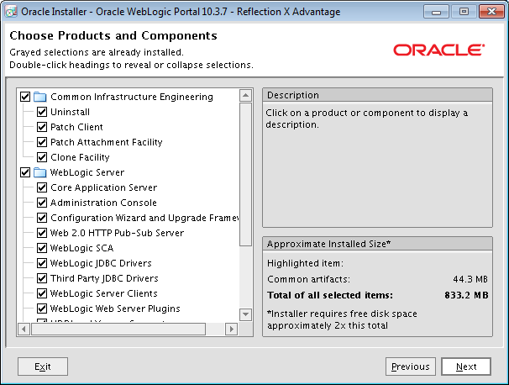

Figure 3: Products and Components Dialogue

1. Accept the defaults on **JDK Selection** dialogue
2. Click **Next**

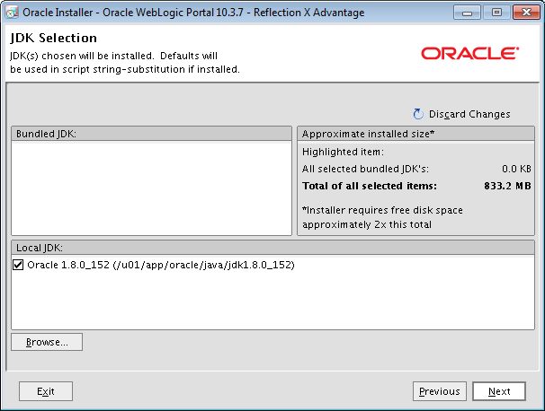

Figure 4: JDK Selection Dialogue

1. Click **Yes**

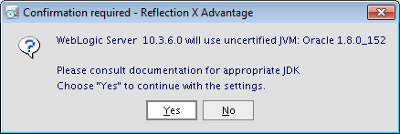

Figure 5: Confirmation Dialogue

1. Verify the paths are correct and click **Next**

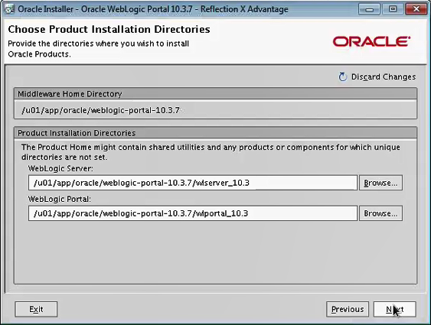

Figure 6: Product Installation Directories

1. Accept the defaults for the **Installation Summary** dialogue
2. Click **Next**

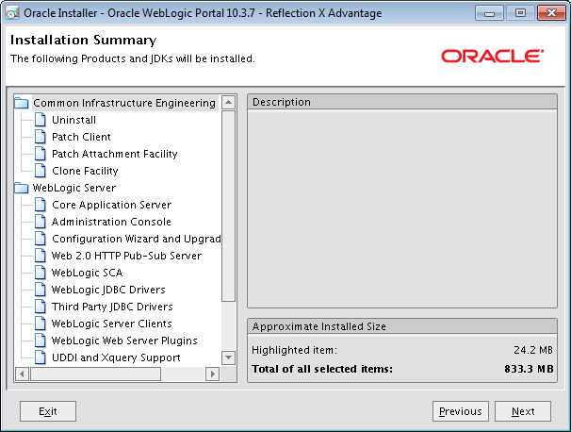

Figure 7: Installation Summary Dialogue

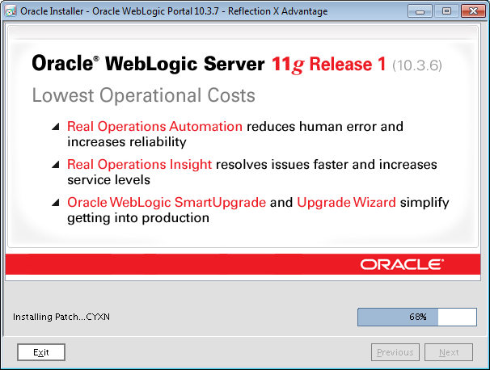

Figure 8: Installing Patch Dialogue

1. Uncheck **Run Quickstart**
2. Click **Done**

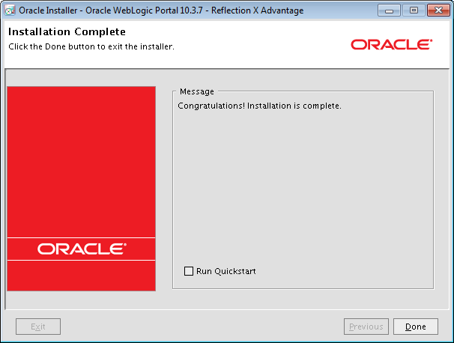

Figure 9: Installation Complete Dialogue

* 1. **Upgrade WebLogic Portal 10.3.6 Domain to WebLogic Portal 10.3.7**

cd /u01/app/oracle/weblogic-portal-10.3.7/wlportal_10.3/common/bin

ll -> -rw-r-----. 1 weblogic weblogic 736 Nov 29 15:18 upgrade.cmd

-rw-r-----. 1 weblogic weblogic 721 Nov 29 15:18 upgrade.sh

chmod +x upgrade.sh

ll -> -rw-r-----. 1 weblogic weblogic 736 Nov 29 15:18 upgrade.cmd

-rwxr-x---. 1 weblogic weblogic 721 Nov 29 15:18 upgrade.sh

./upgrade.sh

1. Click **Next**

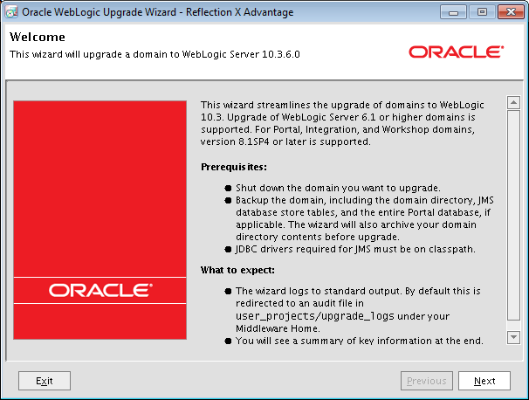

Figure 10: Oracle WebLogic Upgrade Wizard Dialogue

1. Select **9.0 or higher** radio button
2. Click **Next**

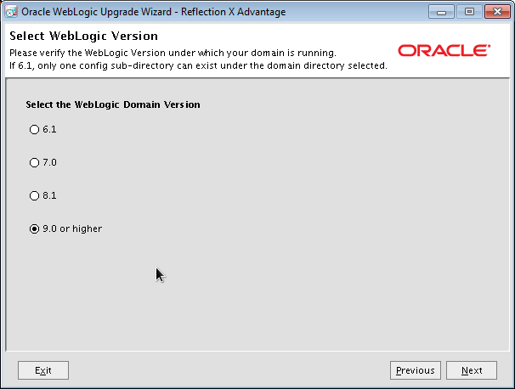

Figure 11: Select WebLogic Version Dialogue

1. Select the specific Domain you are upgrading

**NOTE: FOR PRODUCTION SELECT ihta_prod DOMAIN**

1. Click Next

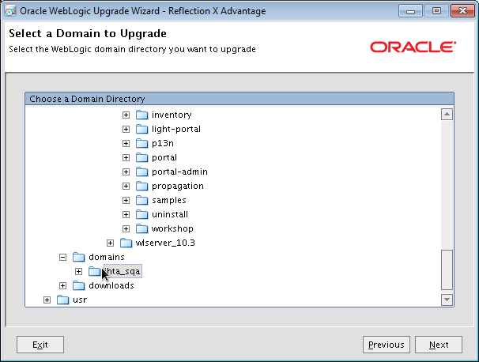

Figure 12: Select Domain to Upgrade Dialogue

1. Select the **AdminServer** radio button
2. Click **Next**

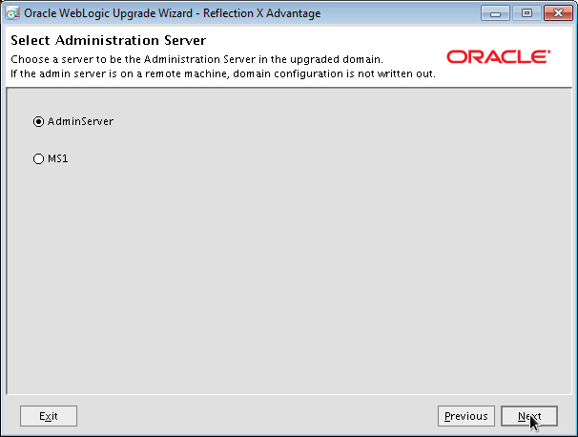

Figure 13: Select Administration Server Dialogue

1. Uncheck **Back up current domain**
2. Click **Next**

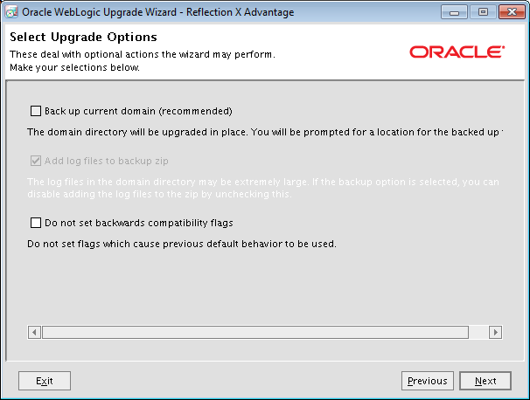

Figure 14: Select Upgrade Options Dialogue

1. Click **Next** from the **Execute P13n Components Domain Upgrade** dialogue

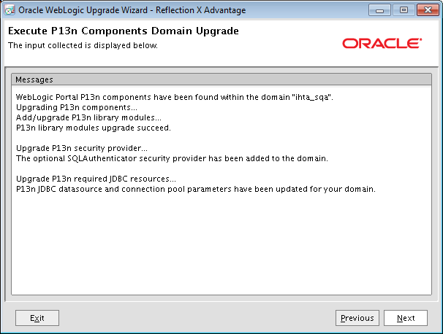

Figure 15: Execute P13n Components Domain Upgrade Dialogue

1. Click **Next** from the **Execute WLP Domain Upgrade Plugins** dialogue

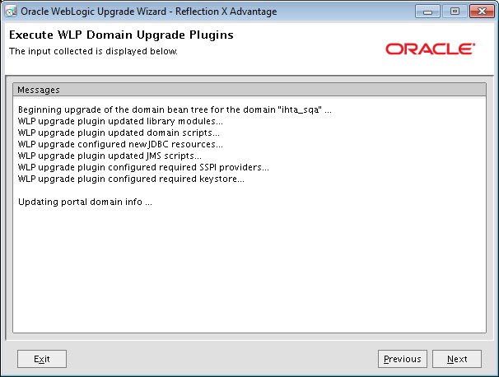

Figure 16: Execute WLP Domain Upgrade Plugins Dialogue

1. Click **Next** from the **Finalize Domain Upgrade** dialogue

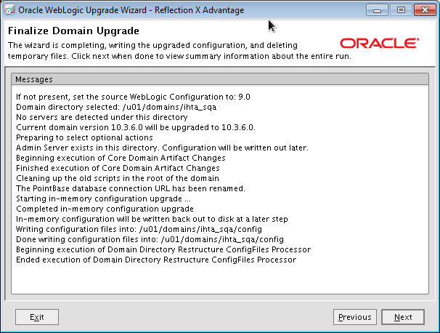

Figure 17: Finalize Domain Upgrade

1. Select **Yes** on the **Database Upgrade Choice** dialogue
2. Click **Next**

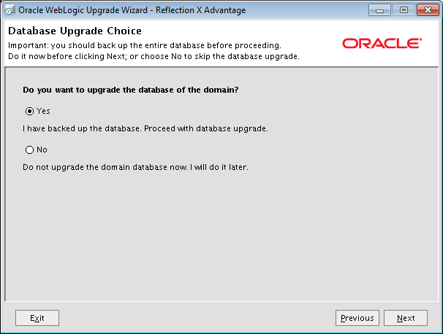

Figure 18: Database Upgrade Choice Dialogue

1. Accept defaults on the **Associate DB Categories with Datasources** dialogue
2. Click **Next**

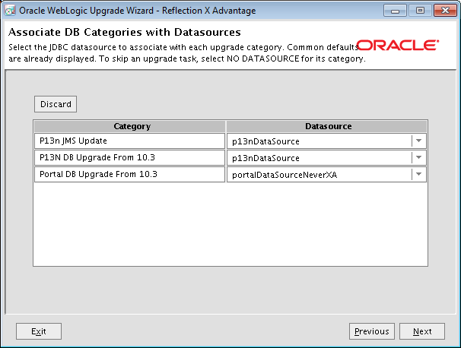

Figure 19: Associate DB Categories with Datasources Dialogue

1. Click **Done** on **Upgrade Complete** dialogue

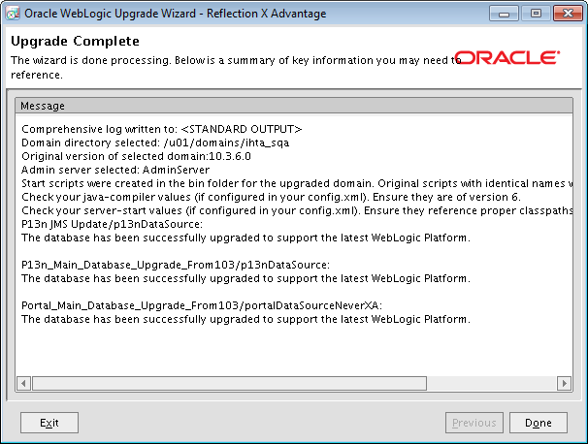

Figure 20: Upgrade Complete Dialogue

* 1. **Post Install and Domain Upgrade steps for WebLogic Portal 10.3.7 Upgrade**

1. Fix config.xml

cd [Note – This will take you back to /home/weblogic]

cd domains/ihta_prod/config

cp config.xml config.xml_bu_YYYYMMDD [Note backup the config.xml file]

grep _10.3.6.0 config.xml [Note: several lines found in file]

sed -i -e 's|_10\.3\.6\.0|_10\.3\.7\.0|g' config.xml

grep _10.3.6.0 config.xml [Note: no lines found in file]

grep 10.3.6 config.xml [Note: two lines found in file as it should be]

grep 10.3.6 config.xml -> <domain-version>10.3.6.0</domain-version>

<configuration-version>10.3.6.0</configuration-version>

1. Fix startWeblogic.sh

cd /u01/domains/ihta_prod

vi startWeblogic.sh -> ${DOMAIN_HOME}/bin/startWebLogic.sh $*

[Note add and ampersand to the end of the line above]

grep startW startWeblogic.sh -> ${DOMAIN_HOME}/bin/**startW**ebLogic.sh $* **&**

1. Fix WLP NodeManager

cd

wlst.sh

wls:/offline> [Note: you should get this prompt]

connect(‘<username>’,’<password>’, ‘t3://###.###.###.###:7101 [Note Where ### = IP Adress]

wls:/ihta_dev/serverConfig> [Note: you should get this prompt]

nmEnroll('/u01/domains/ihta_prod') -> Enrolling this machine with the domain directory at /u01/domains/ihta_prod … Successfully enrolled this machine with the domain directory at /u01/domains/ihta_prod.

exit() -> Exiting WebLogic Scripting Tool.

* 1. **Startup all WebLogic Portal (WLP) Processes Deploy and Start IHTA Application**

cd

domains/ihta_prod/startWeblogic.sh [Note: Start the WLP AdminServer]

startnodemanager.sh prod.properties

appstatus.bsh prod.properties -> [Note: No STATE is displayed]

ls -la domains/ihta_prod/servers/MS1

rm -rf domains/ihta_prod/servers/MS1

ls -la domains/ihta_prod/servers/MS1

deploy.sh prod.properties /u01/domains/ihta_dev/appStage/12.5.0.00701/ccht.war

appstatus.bsh prod.properties -> --- STATE_NEW ---

startserver.sh prod.properties MS1 --- STATE_ACTIVE ---